Bug Report – SFU Author Institution Count Data Quality Issues
Institution: Simon Fraser University (SFU)
OpenAlex Institution ID: I18014758
ROR ID: https://ror.org/0213rcc28

Summary
We queried OpenAlex for authors affiliated with SFU who published between 2020–2024 using the methodology recommended by the OpenAlex team, and obtained a sample of 7,928 unique authors. As a diagnostic step, we examined the distribution of institution counts per author.
The distribution is highly right-skewed: while the median author is associated with 4 institutions and the 75th percentile is 11, the maximum value reaches 1,759 institutions and the mean is 11.35. Manual inspection of the top 100 authors by institution count reveals several distinct data quality issues, including identity disambiguation errors and possible erroneous affiliation assignment. These are described in detail in the Test Cases section below.

Summary Statistics: Institutions per Author

Statistic | Value
Count | 7,928 authors
Mean institutions per author | 11.35
Std deviation | 35.70
Min | 1
25th percentile | 2
50th percentile (median) | 4
75th percentile | 11
Max | 1,759

The histogram below illustrates that most authors have a small number of institutions, but there is a long right tail. Authors appearing in this tail are likely candidates for data quality issues and are the focus of this report.
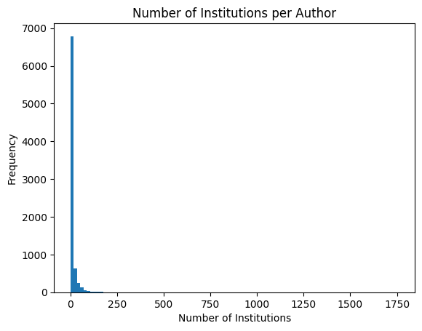

Issues Identified
Manual review of the top 100 authors by institution count revealed two main categories of errors:
- Name disambiguation errors: Authors from different institutions who share a name have been merged into a single OpenAlex author record, causing the record to accumulate institutions from multiple real-world individuals.
- Incorrect affiliation assignment: Authors with no genuine SFU affiliation are being returned by SFU-scoped queries, possibly due to co-authorship with SFU researchers, shared funding, or erroneous lineage/affiliation inheritance.

Test Cases

1. Stephen A. Spector (A5017306542) — Possible Name Disambiguation Error
OpenAlex ID: A5017306542
Observation: An author named Stephen Spector exists as a faculty member at SFU. However, the OpenAlex author record A5017306542 appears to correspond to a healthcare researcher based in San Diego, not the SFU professor. Filtering the author’s works for SFU returns 3 papers legitimately authored by the SFU Stephen Spector.
Hypothesis: This is likely a name disambiguation error. The shared name has caused two distinct individuals to be merged into the same OpenAlex author record.
Impact: This author may be incorrectly surfaced in SFU-scoped queries, and the true SFU author's publication record may be incomplete or misattributed.

2. Ke Li (A5100343450) — Cross-Institution Author Merge
OpenAlex ID: A5100343450
Observation: An author named Ke Li is affiliated with SFU. However, the OpenAlex record A5100343450 appears to have been merged with a different individual by the same name from the University of Exeter. The combined record consequently carries institutions and publications from both individuals.
Hypothesis: Name disambiguation has incorrectly merged two distinct researchers. The resulting combined record overstates the number of institutions and may misattribute publications from one institution's author to the other.
Impact: Inflated institution count for this author. Publication metrics for both the SFU-affiliated Ke Li and the University of Exeter Ke Li may be unreliable within this combined record.

3. Rajeev Gupta (A5100692258) — Possible Erroneous Affiliation Assignment
OpenAlex ID: A5100692258
Observation: Rajeev Gupta does not appear to be an SFU faculty member. This author is nonetheless returned by SFU-scoped author queries. One plausible explanation is that this author co-authored papers with SFU researchers or was involved in federally funded projects with an SFU component, resulting in an incidental or inherited SFU affiliation in OpenAlex.
Hypothesis: This author may have been swept into SFU author results due to co-authorship affiliation assignment or an error in institutional lineage.
Impact: Non-SFU authors appearing in SFU-scoped queries inflate author counts and reduce the precision of institutional queries.

4. Roert S. Hogg (A5034865907) – Legitimate SFU Author with Inflated Institution Count

OpenAlex ID: A5034865907

Observation: Robert S. Hogg is a legitimate SFU-affiliated researcher. However, his OpenAlex record appears in the top 100 authors by institution count, with a number of institutions far exceeding what would be expected for a single researcher. His SFU affiliation is verifiable, confirming this is not a case of a non-SFU author being erroneously included.

Hypothesis: This is likely a name disambiguation error in which one or more other researchers sharing the name Robert Hogg (or similar variants) have been merged into this author's record, bringing their institutional affiliations with them. Alternatively, institutions may have been inherited through co-authorship affiliation assignment at the work level, progressively accumulating across a large publication record.

Impact: The inflated institution count distorts any analysis that uses institution diversity or affiliation history as a signal, and may indicate that some publications credited to this author's record in fact belong to a different individual.

5. Juan Pablo Alperin (A5085171399) — Coauthors incorrectly merged
OpenAlex ID: A5085171399
Observation: Juan Pablo Alperin is a legitimate SFU author, but has more observed institutions in OpenAlex than he has in real life. He also has observed names that do not match his own name, but are the names of some of his coauthors (Erin C. McKiernan, Lesley Schimanski, etc.). The observed institutions of these people are added to Juan’s list of observed institutions.
Hypothesis: This author appears to have absorbed the names and institutions of authors with whom he has coauthored papers in the past.
Impact: Inflation of institution count for Juan, and possible data quality issues for each of the other authors who have been merged into his profile.

Questions for the OpenAlex Team
- What is the recommended way to identify and report suspected name disambiguation errors for specific author IDs? Is there a submission or flagging process?
- Is there a recommended threshold or filter (e.g., maximum institution count, minimum proportion of works with an explicit SFU affiliation string) that can be used to exclude likely-erroneous records from institution-scoped author queries?
- Are there plans to improve disambiguation quality for common names (e.g., Ke Li, Rajeev Gupta) that appear at multiple institutions? If so, is there a mechanism for institutions to submit ground-truth affiliation data to assist disambiguation?

Methodology
Authors were identified using the API methodology recommended by the OpenAlex team for institutional affiliation queries, scoped to Simon Fraser University (Institution ID: I18014758). The query covered publications from 2020–2024. The resulting author list was analyzed by computing the number of distinct institutions per author ID using the affiliations field. The top 100 authors by institution count were manually reviewed against SFU faculty directories, Scopus profiles, and OpenAlex author pages.
We are happy to share the full author list or query scripts if that would assist the OpenAlex team in investigating these issues.

